**. Project Specification**

* 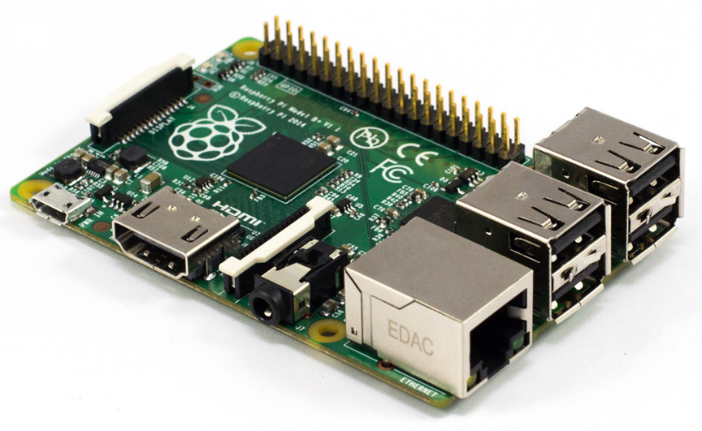Raspberry pi B+
* **Specifications**
* **Chip** Broadcom BCM2835 SoC
* **Core architecture** ARM11
* **CPU** 700 MHz Low Power ARM1176JZFS Applications Processor
* **GPU** Dual Core VideoCore IV® Multimedia Co-Processor
* Provides Open GL ES 2.0, hardware-accelerated OpenVG, and
* 1080p30 H.264 high-profile decode
* Capable of 1Gpixel/s, 1.5Gtexel/s or 24GFLOPs with texture filtering and DMA infrastructure
* **Memory** 512MB SDRAM
* **Operating System Dimensions** 85 x 56 x 17mm
* **Power** Micro USB socket 5V, 2A
* Boots from Micro SD card, running a version of the Linux operating system
* **Connectors:**
* **Ethernet** 10/100 BaseT Ethernet socket
* **Video Output** HDMI (rev 1.3 & 1.4)
* Composite RCA (PAL and NTSC)
* **Audio Output** 3.5mm jack, HDMI
* **USB** 4 x USB 2.0 Connector
* **GPIO Connector** 40-pin 2.54 mm (100 mil) expansion header: 2x20 strip
* Providing 27 GPIO pins as well as +3.3 V, +5 V and GND supply lines
* **Camera Connector** 15-pin MIPI Camera Serial Interface (CSI-2)
* **JTAG** Not populated
* **Display Connector** Display Serial Interface (DSI) 15 way flat flex cable connector
* with two data lanes and a clock lane
* **Memory Card Slot** SDIO
* USB Camera
* Support up to 8 Mega pixels
* Frame rate up to 30fps
* True plug and play easy USB interface
* High quality CMOS sensor
* Clear and sharp motion video capturing
* Whole Project Runs on 12VDC, 1.2Ah lead acid battery.
* Android Mobile Application compatible with all latest Android OS.
* L293D Motor Driver an integrated IC provides peak current of 600mA for each motor
* 12V, 200 RPM DC gear motor for Robot Motion.
* Wifi adapter
* Gives max speed up to 150Mbps
* Plug and play support
* Less power consumption
* Support WPA PSK
* Supported auto connect features
* MQ 2 Gas Sensor
* Good sensitivity to Combustible gas in wide range
* High sensitivity to LPG, Propane and Hydrogen
* Long life and low cost
* Simple drive circuit
* Pick and place Mechanism
* Uses 12V 60RPM DC gear Motor
* Use to lift low weight Load
* Wireless control through android App